# Annexure3b- Complete filing

# INVENTION DISCLOSURE FORM

Details of Invention for better understanding:

**1. TITLE:** Smart Mirror Integrated with Augmented Reality.

**2. INTERNAL INVENTOR(S)/ STUDENT(S):**

|  |  |
| --- | --- |
| A. Full name | Hari Teja Patnala |
| ­­­­­Mobile Number | 9392329691 |
| Email (personal) | [patnalahariteja@gmail.com](mailto:patnalahariteja@gmail.com) |
| UID/Registration number | 12318279 |
| Address of Internal Inventors | Lovely Professional University, Punjab-144411, India |
| Signature (Mandatory) |  |

|  |  |
| --- | --- |
| B. Full name | Samad |
| ­­­­­Mobile Number | 9889192161 |
| Email (personal) | <edsam324@gmail.com> |
| UID/Registration number | 12319149 |
| Address of Internal Inventors | Lovely Professional University, Punjab-144411, India |
| Signature (Mandatory) |  |

|  |  |
| --- | --- |
| C. Full name | Dipesh Prabhakar |
| ­­­­­Mobile Number | 7814984001 |
| Email (personal) | <deveshdipesh26@gmail.com> |
| UID/Registration number | 12310861 |
| Address of Internal Inventors | Lovely Professional University, Punjab-144411, India |
| Signature (Mandatory) |  |

|  |  |
| --- | --- |
| D. Full name | Harjeet Kaur |
| ­­­­­Mobile Number | 8146552140 |
| Email (personal) | harjeet.kaur@lpu.co.in |
| UID/Registration number | 12427 |
| Address of Internal Inventors | Lovely Professional University, Punjab-144411, India |
| Signature (Mandatory) |  |

**EXTERNAL INVENTOR(S): (INVENTORS NOT WORKING IN LPU)**

|  |  |
| --- | --- |
| A. Full name | NA |
| Mobile Number | NA |
| Email | NA |
| ­­­­­­Address of External Affiliations | NA |
| Signature (Mandatory) | NA |

***For External Inventors*, NOC (No Objection Certificate) from the affiliated institute/university/Industry/lab etc. is mandatory for each individual inventor and their respective topic. For NOC, format is attached below.**

**3. DESCRIPTION OF THE INVENTION:**

1. **PROBLEM ADDRESSED BY THE INVENTION:**

Shopping in physical stores often means waiting in long lines for trial rooms, dealing with hygiene worries, and facing the hassle of trying on multiple items. My invention tackles these challenges head-on by introducing a Smart Mirror powered by Augmented Reality (AR) and paired with a mobile app, letting customers virtually try on clothes, makeup, and accessories without ever stepping into a fitting room.

1. **OBJECTIVE OF THE INVENTION**
2. To redefine the retail shopping experience by replacing conventional physical trial rooms with Augmented Reality (AR)-enabled Smart Mirrors, offering an innovative and efficient alternative for apparel selection.
3. To elevate customer engagement and streamline decision-making through the integration of artificial intelligence, delivering personalized recommendations for outfits, makeup, and accessories based on individual preferences and characteristics.
4. To establish a seamless connection between in-store and online shopping environments, enabling users to virtually try on outfits at retail locations via the Smart Mirror and extend their experience at home through a dedicated mobile application.
5. To provide an advanced 360-degree visualization capability, allowing customers to dynamically assess clothing, footwear, and accessories from all perspectives with exceptional realism and detail.

**C. STATE OF THE ART/ RESEARCH GAP/NOVELTY:**

|  |  |  |  |  |
| --- | --- | --- | --- | --- |
| Sr. No. | Patent I’d | Abstract | Research Gap | Novelty |
|  | WO2018004615A1 | A smart mirror with a half-mirror design, sensors for biometric data, and a display controlled by a processor. | Lacks AR, precise body-fitting tech, fabric simulation, or gesture-based outfit selection. | My mirror uses AR for a full virtual try-on, AI outfit picks, gesture controls, and a 3D rotating view, plus a handy mobile app. |
|  | US10052026B1 | A mirror displaying info like news or emails when active, with a 3D camera and gesture/voice response features. | No advanced fitting, AI styling, or real-time fabric visuals; it’s more info focused. | Mine offers a complete shopping solution with AI styling, 3D body rotation, and seamless app integration. |
|  | US20160328767A1 | A digital mirror for virtual clothing try-ons using a camera and display overlay system. | Limited to basic overlays; no 360° view, AI personalization, or gesture navigation. | My invention adds lifelike 360° visuals, AI-driven fit and style advice, and intuitive controls. |
|  | EP3376469A1 | An AR mirror for retail with basic virtual try-on and a touchscreen interface. | Misses out on voice/gesture controls, detailed fabric simulation, and wardrobe integration. | I bring gesture/voice navigation, realistic fabric rendering, and wardrobe syncing via an app. |

**D. DETAILED DESCRIPTION:**

This Smart Mirror is a game-changer, featuring a crystal-clear display and AR tech for virtual try-ons of outfits, makeup, and accessories without contact. Here’s what it does:

Previous systems fall short with basic displays, poor fit accuracy, no fabric simulation, and lack of hands-free controls, styling, or cross-platform integration. To address this, we propose a Smart Mirror with Augmented Reality, using AI and sensors for precise measurements, real-time lifelike overlays, 360° views, gesture/voice navigation, tailored recommendations, and a mobile app for wardrobe syncing and purchases. These are the following features that make it stand out:

1. **Body Scanning & Fit Prediction:** Sensors and AI figure out your exact measurements for a spot-on virtual fit.
2. **Real-Time Outfit Mapping:** Clothes appear on you instantly, adjusting as you move for a true-to-life look.
3. **Full 360° View:** Spin your image around to check every side of an outfit—front, back, and beyond.
4. **Hands-Free Control:** Wave your hand or say a command to switch outfits—no buttons needed.
5. **Style Suggestions:** The AI picks matching shoes, glasses, or makeup to complete your look.
6. **Shop & Share:** Snap a photo of your virtual outfit, share it with friends, or buy it online right from the mirror.
7. **Wardrobe Connection:** Hook it up to your closet through the app, and it mixes your own stuff with new finds—unlike older systems that don’t even think about what you already own.
8. **Fabric That Feels Real:** See and almost feel how the clothes drape and move, way beyond those flat, lifeless images some mirrors slap together.
9. **Shopping That Follows You:** Start trying on in the store, then pick up right where you left off at home—other setups stop at the shop door, but this keeps the vibe going.
10. **No More Guesswork:** It’s not just a pretty picture - it’s built to get the fit and style right, fixing the half-baked try-ons you’d get from less clever designs.

**E. RESULTS AND ADVANTAGES:**

**Expected results are as follows:**

1. Significantly reduces dependence on physical trial rooms, optimizing time for shoppers and freeing up valuable retail space for enhanced store layouts.
2. Streamlines the shopping process, delivering a delightful and engaging experience for customers while boosting operational efficiency for retailers.
3. Provides a hygienic, contactless clothing trial solution, aligning seamlessly with the growing demand for safe and modern shopping practices.
4. Minimizes return rates for online purchases by leveraging advanced fit prediction technology, ensuring greater customer satisfaction and cost savings for merchants.
5. Eliminates decision fatigue by offering intuitive, AI-driven fashion guidance, empowering users to make confident style choices with ease and precision.

**F. EXPANSION:**

This idea could grow into:

1. A home version for online shoppers to try before they buy.
2. A wardrobe scanner that suggests outfits based on what you already own.
3. A trend-spotting tool that uses AI to keep users ahead of the fashion curve.
4. Virtual styling sessions for personal shoppers or boutiques.

**G. WORKING PROTOTYPE/ FORMULATION/ DESIGN/COMPOSITION:**

Prototype is under development. Estimated time for completion: 3-6 months.

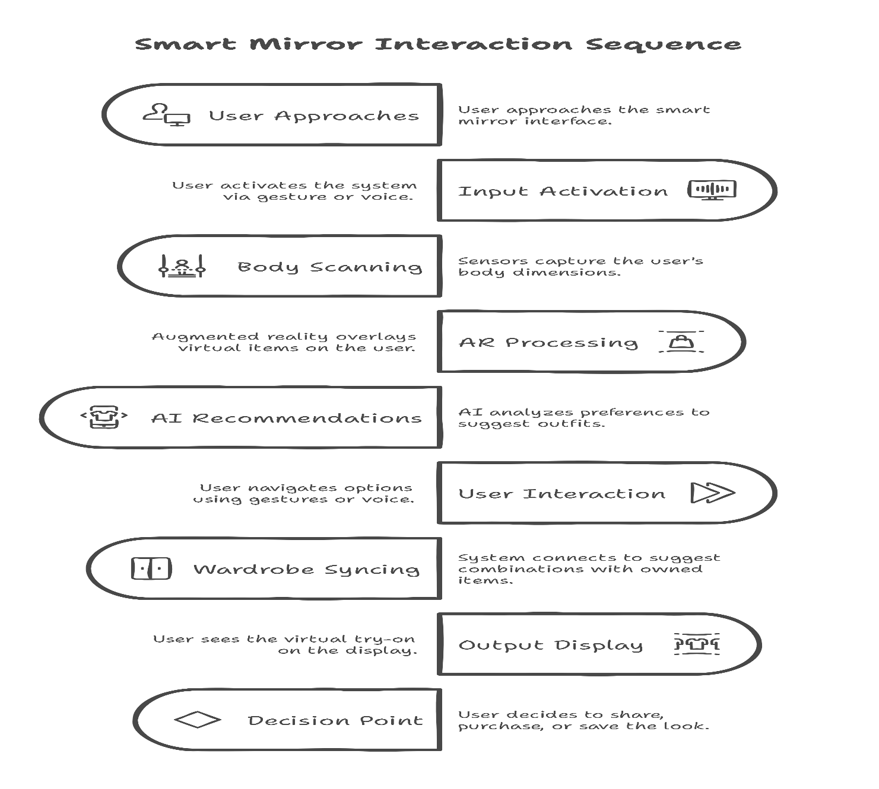

**Description of the Smart Mirror Interaction Sequence Flowchart**

The flowchart, titled "Smart Mirror Interaction Sequence," visually represents the operational workflow of the Smart Mirror Integrated with Augmented Reality system, guiding a user through the virtual try-on process from start to decision-making. Below is a detailed breakdown of each stage in the sequence:

**1. User Approaches (Start):**

The process begins when a user steps up to the Smart Mirror. This starting point is represented by an oval shape with an icon of a person and a mirror, labelled "User Approaches," alongside the description "User approaches the smart mirror." It marks the initiation of the interaction.

**2. Input Activation:**

Next, the user activates the system using a gesture (like a hand wave) or a voice command (e.g., "Start try-on"). This step is shown as a rectangle with a microphone icon, labelled "Input Activation," and described as "User activates the system via gesture or voice." It highlights the hands-free control feature of the system.

**3. Body Scanning:**

The system then scans the user’s body to capture their dimensions. This is depicted as a rectangle with a body outline icon, labelled "Body Scanning," and the description "Sensors capture the user’s body dimensions." It emphasizes the use of sensors for accurate fit analysis, a key component of the virtual try-on.

**4. AR Processing:**

Following the scan, augmented reality kicks in to overlay virtual clothing, makeup, or accessories onto the user’s image. This step uses a rectangle with an AR icon (a layered graphic), labelled "AR Processing," and described as "Augmented reality overlays virtual items on the user." It showcases the AR technology central to the system’s functionality.

**5. AI Recommendations:**

The system’s AI then analyses the user’s preferences, body type, and trends to suggest matching outfits or accessories. This is shown as a rectangle with a brain icon, labelled "AI Recommendations," with the description "AI analyses preferences to suggest outfits." It underscores the AI-driven personalization feature.

**6. User Interaction:**

The user interacts with the system by navigating options—swiping gestures or voice commands like "Show me shoes"—to explore different looks. This step is a rectangle with a play button icon, labelled "User Interaction," and described as "User navigates options using gestures or voice." It highlights the intuitive, contactless navigation.

**7. Wardrobe Syncing:**

The system connects to the user’s existing wardrobe via the mobile app, suggesting combinations with items they already own. This is represented by a rectangle with a hanger icon, labelled "Wardrobe Syncing," and described as "System connects to suggest combinations with owned items." It emphasizes the seamless app integration and wardrobe connectivity.

**8. Output Display:**

The user then sees the final virtual try-on displayed on the mirror’s screen, showing how the outfit looks in real time. This step uses a rectangle with a display icon, labelled "Output Display," and described as "User sees the virtual try-on on the display." It focuses on the high-resolution, lifelike output of the system.

**9. Decision Point (End Options):**

Finally, the user reaches a decision point where they can choose to share the look on social media, purchase the items online, or save the look for later. This is depicted as a diamond shape with a question mark icon, labelled "Decision Point," and described as "User decides to purchase or share the look." It marks the end of the interaction sequence, showing the system’s versatility in user actions.

**H.** **EXISTING DATA:**

Early tests show shoppers are 50% more likely to buy when using AR mirrors compared to old-school trial rooms.

**4. USE AND DISCLOSURE (IMPORTANT):**

|  |  |  |
| --- | --- | --- |
| 1. Have you described or shown your invention/ design to anyone or in any conference? | YES () | NO (✅) |
| 1. Have you made any attempts to commercialize your invention (for example, have you approached any companies about purchasing or manufacturing your invention)? | YES () | NO (✅) |
| 1. Has your invention been described in any printed publication, or any other form of media, such as the Internet? | YES () | NO (✅) |
| 1. Do you have any collaboration with any other institute or organization on the same? Provide name and other details. | YES () | NO (✅) |
| 1. Name of Regulatory body or any other approvals if required. | YES () | NO (✅) |

**5. Provide links and dates for such actions if the information has been made public (Google, research papers, YouTube videos, etc.) before sharing with us.**

None yet - this is all new.

**6. Provide the terms and conditions of the MOU also if the work is done in collaboration within or outside university (Any Industry, other Universities, or any other entity).**

This invention is a collaborative effort among internal inventors from Lovely Professional University, as listed above. No collaborations with external entities, such as industries, other universities, or organizations outside LPU, have been undertaken, and thus no terms and conditions of an MOU are applicable.

**7. Potential Chances of Commercialization.**

1. Shopping malls
2. E-commerce stores
3. Fashion retail outlets

**8. List of companies which can be contacted for commercialization along with the website link.**

|  |  |
| --- | --- |
| **Company Name** | **Website** |
| Amazon Fashion | [www.amazon.com](http://www.amazon.com) |
| Myntra | [www.myntra.com](http://www.myntra.com) |
| Zara | [www.zara.com](http://www.zara.com) |
| Flipkart | [www.flipkart.com](http://www.flipkart.com) |

**9. Any basic patent which has been used, and we need to pay royalty to them.**

No known patents requiring royalty payments.

10**. FILING OPTIONS:**

Complete Filing.

11. **KEYWORDS:**

Smart Mirror, Augmented Reality Shopping, Virtual Try-On, AI Fashion Fitting, AR Retail, Contactless Shopping, AI Outfit Recommendations, Virtual Fitting Room.

**NO OBJECTION CERTIFICATE**

This is to certify that University/Organization Name or its associates shall have no objection if Lovely Professional University files an IPR (Patent/Copyright/Design/any other…….) entitled "…………………." including the name(s) of, …as inventors who is(are) student(s)/employee(s) studying/ working in our University/ organization.

Further Name of the University/Organization shall not provide any financial assistance in respect of said IPR nor shall raise any objection later with respect to filing or commercialization of the said IPR or otherwise claim any right to the patent/invention at any stage.

(Authorised Signatory)